**GONZAGA UNIVERSITY**

**School of Engineering and Applied Science**

**Center for Engineering Design and Entrepreneurship**

**Medcurity Network Inventory**

**Project Overview**

**Plan Section 01**

**Release:**

**Draft v0.1**

**PROJECT PLAN DRAFT STAGE DOCUMENT**

**September 13, 2023**

**Medcurity Network Inventory Team**

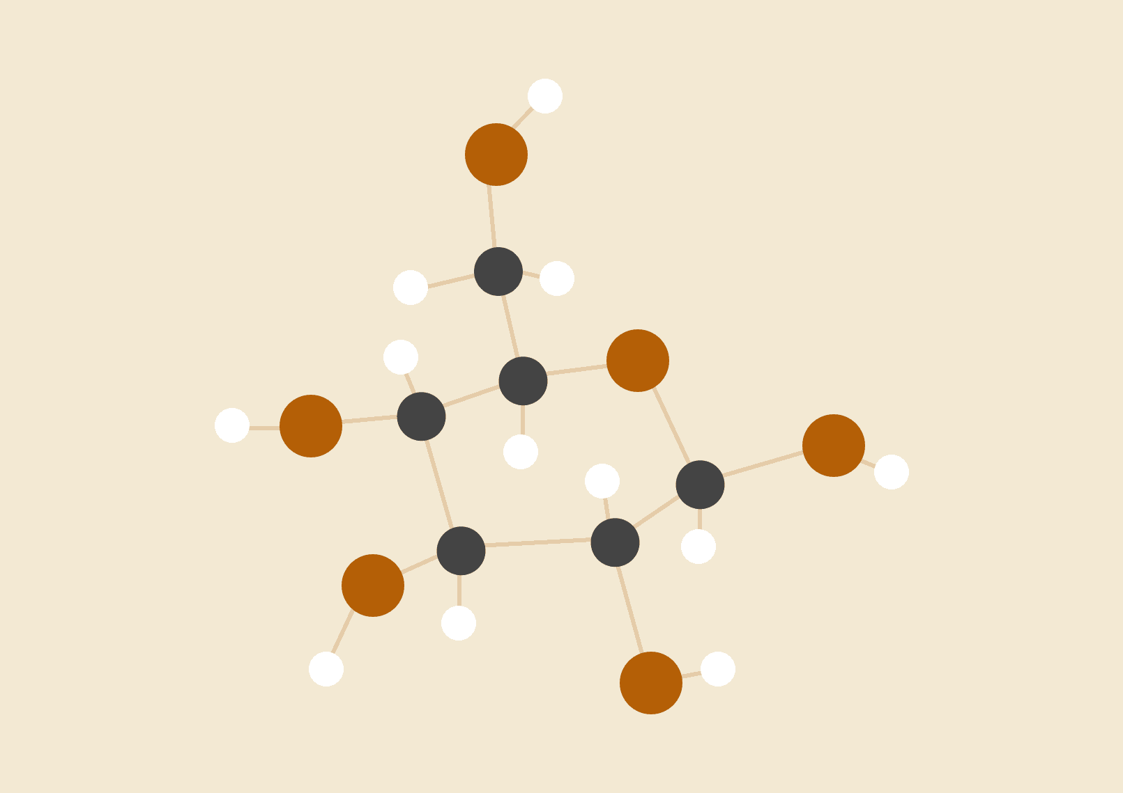

**Brandon Huyck**

**Colleen Lemak**

**Artis Nateephaisan**

**Jack Nealon**

**1 Project Overview**

**1.1 Project Summary**

Provide a clear and concise two-paragraph summary of your project. The first paragraph of the summary must provide a high level description of your project’s “why” (i.e., the problem the project is trying to address) and the second paragraph your project’s “what” (i.e., how your project is going to address the problem). The summary should be written for someone who is unfamiliar with the project domain (including jargon used within the domain).

Online scammers and hackers are capable of ensuing serious damages. Whether attacks are motivated by ransom money, power, or status, individuals and companies are at high risk, especially since professions, especially in the medical field, handle large amounts of sensitive and private data. Digital security breaches and malicious ransomware attacks plague institutions, and one of the victims was our Sponsor, Medcurity, and its network. Thus, it is crucial to engineer layers of security to ensure private medical records are kept confidential in order to guarantee client safety and data protection. Adhering to medical record compliance protects sensitive patient health information from being disclosed without patient consent or knowledge and in turn follows federal digital security standards, known as *HIPAA* standards.

Our software inventory tool addresses cyberthreats by implementing an administrator login page and scanning the client’s network to output a customized report based on client needs and active software on the Sponsor’s network. Identifying devices and software within the industry’s domain will demystify connections to the network that may not be safe to allow in the network. Allowing for transparency and control within the network is crucial for any dependable, trustworthy, and secure integrated tool. To parse through reports, we will have an in-scope database to record and output readable and succinct information usable to the client and administrator. Additionally, to scan for devices after logging into the administrator page, we will generate requests to communicate with and detect other devices, using web applications.

**1.2 Project Objectives**

Provide a description of the major project business objectives (i.e., business goals/desired outcomes of the project). Be sure each objective is concrete, specific, measurable, and has been vetted with your project sponsor/liaison.

The main desired outcome of the Medcurity Network Inventory Team is to develop a new tool that complies to HIPAA standards and can be used by the sponsor to help in their goal of organizing, managing, and controlling the numerous tasks healthcare organizations are responsible for. The tool must be able to scan a client’s network for devices that are currently connected to it and be able to use the sponsor’s existing software to identify the client’s needs and diagnose issues. The solution should be integrated seamlessly into the sponsor’s current software environment and be able to output customized reports that have filtering capabilities and are easy to read.

**1.3 Project Stakeholders**

Provide a brief description of the main stakeholders of the project. This should include yourselves as developers, your project sponsor and liaison, your faculty advisor, your design advisory board members, and the target user communities you are building your product for (note that there may be multiple potential user communities being targeted). For each concrete project stakeholder, be sure to include their affiliation (organization) and their role in the project. Describe your target user communities in enough detail to give the reader confidence you understand the needs of these groups relevant for your project.

The main stakeholders of the project include our Liaisons, Rachel Kunkel and Amanda Hepper, who are both directly affiliated with Medcurity. They are responsible for communicating with the Medcurity Network Inventory Team, relaying specifications for the project, and addressing any overall questions the team may have.

The design advisory board (DAB) member, Richard Weeks, who works at F5 as a version control specialist, is responsible for giving advice and guidance. Since the DAB members have had experiences in past projects and qualifications, they are able to provide a different perspective to the rest of the team and are able to help solve specific technical issues the team may run into.

Similar to the DAB member, the advisor, Mike Mudge, who is a senior manager at Avista, provides guidance to the team. Unlike the DAB member, the advisor is responsible for guidance relating to the high-level aspects of the project. They are also responsible for evaluating the team’s progress, routinely checking up with them to ensure they are on pace to complete their project.

The main developers are the students at Gonzaga University, Brandon, Colleen, Artis, and Jack. They are responsible for the majority of the project work and are expected to collaborate through good communication, organization, and providing unique perspectives to any given scenario. Their work and their process aligns with what their future career will potentially look like.

Along with the DAB member the Medcurity IT department members are the ones likely to provide the team specific information regarding the content of the project. Since they are responsible for upholding the current software systems at Medcurity, they will be able to give tips and warnings on how the team will integrate the new software tool that will become a part of their current system.

The network management departments are a part of the general industry. The team’s work is going to contribute to Medcurity’s systems, which are involved in the network management systems. This means it is important to consider the general industry standards relating to this subject when the team is assembling their software solution as it may lead to unforeseen circumstances.

**1.4 Project Deliverables**

Provide a brief description of each project deliverable. The main deliverable will be the software product you are developing. Other deliverables may include software documentation (e.g., a users or developers manual), a software installer, performance evaluation results, maintenance plans, etc. For each deliverable give a description of what it will generally include and how it will be delivered and/or deployed.

The main deliverable will be the software tool as described in 1.2 and 1.5 to be integrated into Medcurity’s website and products. In addition, documentation for users and future developers, testing methods and results, and a report describing the future work that could be added will be provided. All of this will be submitted via a Git repository.

**1.5 Project Scope**

Provide a brief description of the project scope that states what aspects of the project already exist (out of scope) versus what aspects you will be developing from scratch (in scope). Your description must be accompanied by a high-level context diagram, highlighting the components that are outside of the scope of your project and how they will generally interact with your system.

* Out of scope
  + Medcurity web tool that will api/exe our tool
* In scope
  + A tool that will scrape the network its being run on, cataloging devices and software it finds
  + A database to store what the agent finds

This project has two in-scope features: the agent that scrapes the network for devices and software, and the database that stores the devices and software that the agent finds. That which is out of scope includes the Medcurity web tool that the agent and database will be integrated into. The web tool will send the agent out to the network, the agent will update the database, and the database will return itself to the web tool.

|  |
| --- |

**Figure 1**

**1.6 Related Work**

Provide a description of existing systems and/or approaches that try to solve a similar problem as yours. Identify and describe the system most-closely related to the one you are planning on building, discussing both the similarities and the differences between this system and yours. Additionally, summarize the major similarities and differences of those less related, but still similar to your project. The goal of this section is to show that you have examined and understand the product landscape and have a clear idea of the needs of your project and how they are similar and different to the current systems/approaches available. Provide a link or reference (as a footnote) to each system you describe.

As a main component of our project, working with security and IT management, there are many software development companies that invest in and offer network scanning and device-tracking applications along with supporting management software.

Auvik[1] —

The network management system offered by Auvik Networks provides real-time network discovery and mapping by collecting data from various sources allowing users to visualize their network's structure and understand how devices are connected, mirroring our project plans. Additionally, Auvik automates inventory and documentation, capturing information including the device’s make, model, serial number, IP address, and switchport connections. These additional features lie outside of our current project plans but could potentially be implemented after initial designs with sponsor’s permission. Lastly, the Auvik program assists in hardware lifecycle management by identifying devices that may need upgrades or replacements. It retrieves data about support contracts, available software updates, security patch eligibility, and device availability for purchase. This feature will also not be included in our project plans.

Famatech[2] —

Provided by the Famatech corporation, the “Advanced IP Scanner” shows all the connected network devices and provides remote control of computers via RDP and Radmin. Additionally, the program also gives the user access to shared folders. Comparing this software to our project, the only major difference is that the Advanced IP Scanner uses Radmin, a third-party company, for remote connection.

SolarWinds[3] —-

The “User Device Tracker” offered by SolarWinds shares some close similarities with the plans we have for our project and has some shared functionality. Altogether, shared functionalities include the ability for the client to identify users and devices on their network with a comprehensive network topology and store that in a database for further analysis. Additionally, the SolarWinds program offers an active directory integration with an interactable interface allowing the user to whitelist hosts, track sensitive or suspicious devices and remotely turn switch ports on and off. As for current plans, this additional functionality offered by the SolarWinds program is not planned for our project, however, can be added as potential features to be added after initial development.

1. Auvik Network Management - <https://www.auvik.com/features/>
2. Famatech Advanced IP Scanner - <https://www.advanced-ip-scanner.com/>
3. SolarWinds User Device Tracker - <https://www.solarwinds.com/user-device-tracker>